Project Title: Transforming healthcare with Al-powered disease prediction based on patient data

PHASE-3
1. Problem Statement
The healthcare industry faces significant challenges in providing timely and accurate diagnoses, leading to delayed treatments, increased healthcare costs, and suboptimal patient outcomes. Traditional diagnostic methods often rely on subjective assessments and may not fully utilize the vast amounts of patient data available. With the advent of artificial intelligence (AI), there is a transformative opportunity to enhance disease prediction by leveraging comprehensive patient data, including electronic health records (EHRs), medical imaging, genomics, and lifestyle information.
2. Abstract
The integration of Artificial Intelligence (AI) into healthcare has ushered in a transformative era, enabling the shift from reactive treatment to proactive, personalized care. By harnessing vast datasets—including electronic health records, medical imaging, genomics, and lifestyle information—AI systems can predict disease onset and progression with unprecedented accuracy. This capability facilitates early detection, allowing for timely interventions that can significantly improve patient outcomes and reduce healthcare costs.
3. System Requirements
1. Data Acquisition & Integration:
- Electronic Health Records (EHRs): Utilize standardized formats like HL7 and FHIR for interoperability.
- Medical Imaging: Incorporate DICOM standards for radiology and ophthalmology data.
- Wearables & IoT Devices: Integrate data from devices monitoring vital signs and other health metrics.
2.Data Preprocessing & Feature Engineering:
- Data Cleaning: Handle missing values, outliers, and inconsistencies.
- Normalization: Standardize data to ensure uniformity across datasets.
- Feature Selection: Identify and select relevant features to improve model performance.
3.AI Model Development:
- Machine Learning Framework: Employ tools like Scikit-learn, TensorFlow, or PyTorch.
- Model Types: Utilize algorithms such as Random Forest, SVM, and Neural Networks.
- Ensemble Methods: Combine multiple models to enhance prediction accuracy.
4. Model Training & Validation:
- Training Data: Use diverse datasets to ensure model generalization.
- Validation Techniques: Implement cross-validation to assess model performance.
- Performance Metrics: Evaluate models using metrics like accuracy, precision, recall, and AUC.
5. Deployment & Inference:
- Cloud Infrastructure: Utilize platforms like AWS, Azure, or Google Cloud for scalability.
- Edge Computing: Deploy models on local devices for real-time predictions.
- APIs: Develop interfaces for seamless integration with existing systems.
6.User Interface & Reporting:
- Dashboards: Provide visualizations for healthcare professionals.
- Alerts: Implement notification systems for critical predictions.
- Report Generation: Automate the creation of patient-specific reports.
4. Objectives

1. Early Detection and Prevention:
AI models analyze patient data to identify early signs of diseases such as cancer, cardiovascular conditions, and diabetes, facilitating timely interventions. For instance, AI algorithms can detect subtle patterns in medical images or vital signs that may indicate the onset of a disease, enabling healthcare providers to initiate preventive measures before symptoms become severe.

2. Personalized Treatment Plans:
By considering individual factors like genetics, lifestyle, and medical history, AI systems can recommend tailored treatment strategies. This personalized approach enhances the effectiveness of interventions and minimizes adverse effects. For example, AI can predict a patient's response to specific medications, allowing clinicians to select the most appropriate therapy.

3. Predicting Disease Progression:
AI models can forecast the trajectory of chronic diseases, assisting healthcare providers in planning long-term care and resource allocation. By analyzing trends in patient data, AI can predict potential complications or disease progression, enabling proactive management.

4. Enhancing Diagnostic Accuracy:
AI enhances the precision of diagnoses by analyzing large datasets, including medical images and lab results, to identify patterns that may be overlooked by human clinicians. This leads to more accurate and timely diagnoses, reducing the likelihood of misdiagnoses.

5. Reducing Healthcare Costs:
Early detection and personalized treatment plans can lead to more efficient use of healthcare resources, reducing the need for emergency interventions and hospitalizations. By preventing disease progression and optimizing treatment strategies, AI contributes to cost savings in the healthcare system.

6. Facilitating Remote Monitoring and Alerts:
AI-powered wearable devices and health monitoring tools can continuously track a patient's vital signs and health metrics, offering real-time data to both patients and healthcare providers. These tools use AI to detect early warning signs of potential health issues, such as abnormal heart rhythms, changes in blood pressure, or glucose levels, prompting timely interventions.

7. Supporting Public Health Initiatives:
AI analyzes health data from various sources to identify trends and predict disease outbreaks, aiding in public health planning and response. By forecasting the spread of infectious diseases and identifying at-risk populations, AI supports targeted interventions and resource allocation

5. Flowchart of the Project Workflow:

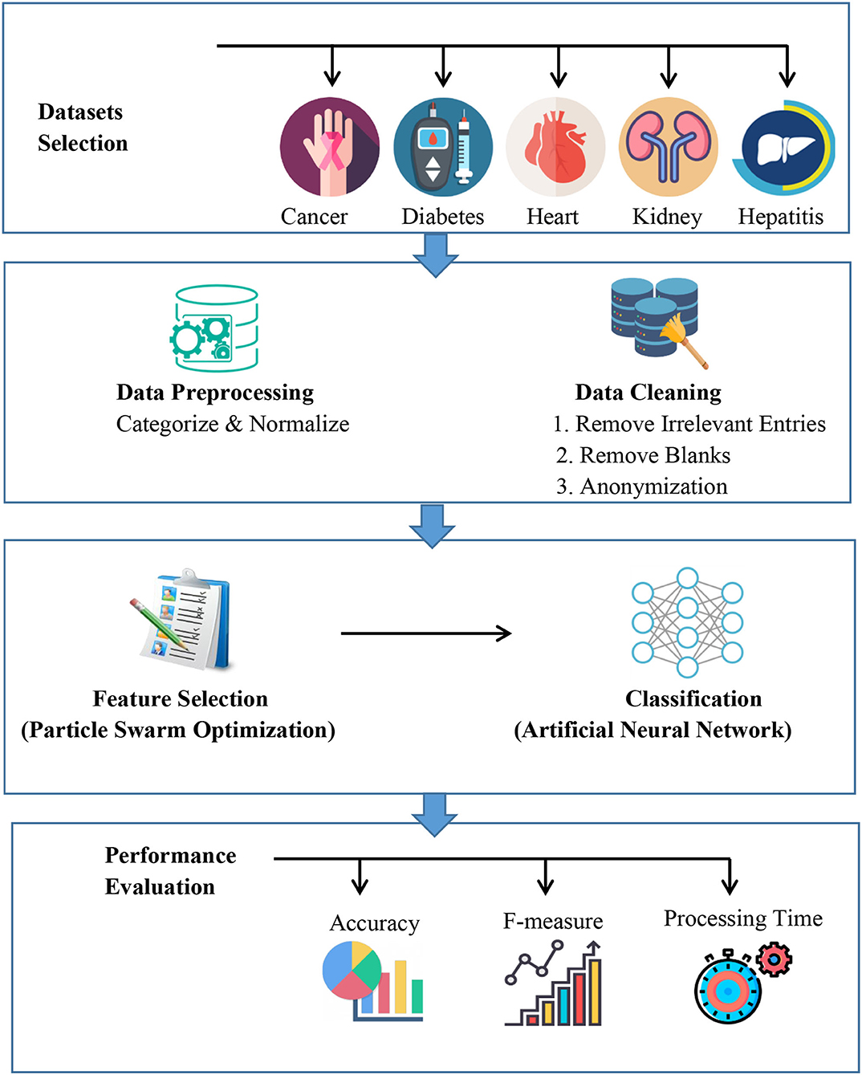

6. Dataset Description :

Common Features in Healthcare Datasets
- Demographic Information:
  - Age: Patient's age in years.
  - Sex/Gender: Categorical variable indicating male or female.
  - Ethnicity: Patient's ethnic background.
- Clinical Measurements:
  - Blood Pressure: Systolic and diastolic blood pressure readings.
  - Cholesterol Levels: Serum cholesterol levels.
  - Blood Sugar Levels: Fasting blood sugar levels.
  - Heart Rate: Maximum heart rate achieved during exercise.
  - ECG Results: Electrocardiogram readings

- Lifestyle Factors:
  - Smoking Status: Whether the patient smokes.
  - Alcohol Consumption: Frequency of alcohol intake.
  - Physical Activity: Level of physical activity.
  - Dietary Habits: Nutritional intake patterns.

- Medical History:
  - Previous Diagnoses: History of past illnesses.
  - Medications: Current and past medications.
  - Family History: Genetic predispositions to certain diseases.

- Outcome Variable:
  - Disease Status: Presence or absence of a specific disease, such as heart disease, diabetes, or cancer.

Example Datasets:

1.Heart Disease Cleveland Dataset:
- Contains 14 features including age, sex, chest pain type, resting blood pressure, cholesterol levels, and others. The target variable indicates the presence or absence of heart disease.
2.Pima Indians Diabetes Dataset:
- Includes 8 attributes such as number of pregnancies, glucose concentration, blood pressure, and BMI. The outcome variable indicates whether the patient has diabetes.

3.UK Biobank:
- A comprehensive dataset with data from over 500,000 participants, including genetic, lifestyle, and health information, used for various disease prediction studies.

Real-World Applications:
- Early Disease Detection:
  - AI models can predict the likelihood of diseases like heart disease or diabetes, enabling early interventions.
- Personalized Treatment Plans:
  - By analyzing patient data, AI can assist in developing tailored treatment strategies.
- Resource Allocation:
  - Predictive models help in efficient allocation of healthcare resources by identifying high-risk patients.

7.Data Preprocessing:
1.Data Cleaning:
- Handling Missing Values: Employ advanced imputation methods like k-Nearest Neighbors (KNN), matrix factorization, or Generative Adversarial Networks (GANs) to replace missing data, preserving the dataset's integrity.
- Outlier Detection and Removal: Identify and address anomalies that could skew model predictions, ensuring the data reflects realistic patient scenarios.
- Noise Reduction: Apply smoothing techniques to minimize random variations, enhancing the signal quality in the data.

2. Data Transformation
- Normalization and Scaling: Adjust data to a standard range, such as [0, 1], to prevent features with larger scales from dominating model behavior .
- Encoding Categorical Variables: Convert non-numeric data into numerical formats using techniques like one-hot encoding or label encoding, making them suitable for machine learning algorithms.
- Feature Engineering: Derive new variables, such as calculating Body Mass Index (BMI) from weight and height, to provide deeper insights into patient health.

3. Data Reduction
- Dimensionality Reduction: Utilize methods like Principal Component Analysis (PCA) to reduce the number of features, focusing on the most informative ones and improving model efficiency.
- Feature Selection: Identify and retain the most relevant features, eliminating redundant or irrelevant ones to enhance model performance.
4. Data Balancing
- Addressing Class Imbalance: Implement techniques such as Synthetic Minority Over-sampling Technique (SMOTE) or Random Oversampling to balance datasets where certain outcomes (e.g., rare diseases) are underrepresented .

5. Integration and Standardization
- Combining Data Sources: Merge data from diverse sources like Electronic Health Records (EHRs), lab results, and wearable devices, ensuring consistency and compatibility.
- Schema Matching: Align different data formats and structures to create a unified dataset, facilitating comprehensive analysis .

8. Exploratory Data Analysis (EDA)
- dentifying Significant Risk Factors: EDA helps in pinpointing critical variables influencing disease outcomes. For instance, in heart disease prediction, factors like chest pain type, maximum heart rate achieved, and the number of major vessels colored by fluoroscopy have been identified as significant predictors
- Data Quality Assessment: Through EDA, healthcare professionals can assess the quality of data by identifying missing values, outliers, and inconsistencies, ensuring the reliability of predictive models.
- Feature Engineering and Selection: EDA facilitates the creation of new features and the selection of relevant variables, enhancing model performance and interpretability.
- Visualization of Data Distributions: Using tools like histograms and box plots, EDA allows for the visualization of data distributions, aiding in the understanding of underlying patterns and trends.
- Correlation Analysis: EDA involves examining relationships between variables, which can reveal multicollinearity and inform the selection of features for modeling.

9. Feature Engineering
• Data Imputation: Addressing missing values using techniques like K-Nearest Neighbors (KNN) imputation to maintain data integrity and improve model accuracy.
• Variable Transformation: Applying transformations such as log or square root to skewed data, like BMI, to stabilize variance and make patterns more discernible.
• Encoding Categorical Variables: Utilizing one-hot or target encoding for categorical features to convert them into formats suitable for machine learning models.
• Feature Creation and Selection: Generating new features through aggregation or decomposition and selecting the most relevant ones to enhance model performance.
• Normalization and Scaling: Standardizing numerical features to a common scale to prevent any single feature from dominating the model due to its magnitude.
• Interaction Terms: Creating features that capture interactions between variables, such as age and medication adherence, to uncover hidden relationships and improve predictive accuracy.
• Dimensionality Reduction: Applying techniques like Principal Component Analysis (PCA) to reduce the number of features while retaining essential information, enhancing model efficiency.
• Incorporating Domain Knowledge: Engaging clinicians to identify and prioritize features that are clinically relevant, improving model interpretability and adoption.

10.Model Building Process:
- Data Collection: Gather comprehensive patient data, including electronic health records (EHR), medical imaging, and wearable device outputs.
- Data Preprocessing: Clean and preprocess the data by handling missing values, normalizing numerical features, and encoding categorical variables.
- Feature Engineering: Create meaningful features that capture essential patterns, such as aggregating lab results or deriving risk scores.
- Model Selection: Choose appropriate machine learning algorithms based on the nature of the data and the prediction task.
- Model Training: Train the selected model on a training dataset, tuning hyperparameters to optimize performance.
- Model Evaluation: Assess the model's performance using metrics like accuracy, precision, recall, and the area under the receiver operating characteristic curve (AUC-ROC).
- Model Validation: Validate the model on an independent dataset to ensure generalizability and prevent overfitting.
- Model Deployment: Integrate the model into clinical workflows, ensuring it can process real-time patient data and provide actionable insights.
11. Deployment:

Deployment Strategies for AI in Healthcare

1. Cloud-Based Deployment:
Utilizing cloud platforms like Microsoft Azure, AWS, or Google Cloud enables scalable and accessible deployment of AI models. For instance, a heart disease prediction system was deployed on Microsoft Azure using Python libraries such as pickle and Flask, allowing remote access and real-time predictions, which is particularly beneficial for underserved regions .

2. Edge and IoT Integration:
Integrating AI models with Internet of Things (IoT) devices facilitates real-time monitoring and prediction at the point of care. For example, wearable devices can collect patient data, which is then processed locally or in the cloud to provide immediate insights, enhancing patient outcomes through timely interventions.

3.Federated Learning:
Federated learning allows multiple healthcare institutions to collaboratively train AI models without sharing sensitive patient data. This approach maintains data privacy while enabling the development of robust models. Notably, federated learning has been applied in predicting clinical outcomes for COVID-19 patients, demonstrating its efficacy in healthcare settings .

4.Batch and Real-Time Scoring
Depending on the application, AI models can be deployed for batch processing or real-time scoring:
- Batch Processing: Suitable for non-urgent analyses, such as periodic risk assessments.
- Real-Time Scoring: Critical for immediate decision-making, such as predicting arrhythmias during surgery. For example, the NHS in England is trialing an AI tool to predict fatal heart disease using real-time ECG data.

5.Model Monitoring and Maintenance:
Continuous monitoring of deployed models ensures they maintain accuracy and relevance over time. This includes tracking performance metrics, updating models with new data, and addressing any drift in model predictions to adapt to changing patient populations and healthcare environments
13. Source Code
# disease_prediction.py

import pandas as pd
from sklearn.model_selection import train_test_split
from sklearn.preprocessing import StandardScaler
from sklearn.linear_model import LogisticRegression
from sklearn.metrics import classification_report, accuracy_score

# Load sample dataset (replace with actual patient data)
# Sample: UCI diabetes dataset
url = "https://raw.githubusercontent.com/jbrownlee/Datasets/master/pima-indians-diabetes.data.csv"
column_names = ['Pregnancies', 'Glucose', 'BloodPressure', 'SkinThickness',
'Insulin', 'BMI', 'DiabetesPedigreeFunction', 'Age', 'Outcome']
data = pd.read_csv(url, header=None, names=column_names)

# Prepare features and target
X = data.drop('Outcome', axis=1)
y = data['Outcome']

# Train/test split
X_train, X_test, y_train, y_test = train_test_split(X, y, test_size=0.2, random_state=42)

# Standardize features
scaler = StandardScaler()
X_train = scaler.fit_transform(X_train)
X_test = scaler.transform(X_test)

# Train model
model = LogisticRegression()
model.fit(X_train, y_train)

# Make predictions
y_pred = model.predict(X_test)

# Evaluate model
print("Accuracy:", accuracy_score(y_test, y_pred))
print("Classification Report:\n", classification_report(y_test, y_pred))

14. Future Scope:

1.Integration of Multimodal Data for Holistic Health Insights
AI systems will increasingly analyze diverse data types—such as electronic health records, medical imaging, genomic sequences, and real-time sensor data—to create comprehensive patient profiles. This multimodal approach will enhance diagnostic accuracy and enable more personalized treatment plans.

2. Advancements in Predictive Analytics for Early Disease Detection
Machine learning models will evolve to predict the onset of diseases like cancer, dementia, and cardiovascular conditions with greater precision. For instance, AI tools are being developed to analyze hospital records for early signs of dementia, potentially identifying high-risk individuals before clinical symptoms emerge.

3.Expansion of AI in Public Health Surveillance:
AI will play a crucial role in monitoring and predicting public health threats. By analyzing global health data, AI systems can forecast disease outbreaks, such as influenza or COVID-19, enabling timely interventions and resource allocation.

4. Enhanced Personalized Medicine through Genomic Analysis:
AI's ability to process and interpret genomic data will lead to more effective personalized treatments. By 2025, AI models are expected to analyze whole-genome sequencing data from large patient cohorts, improving the detection of rare genetic variants and tailoring therapies accordingly.

6.Development of Autonomous AI Agents in Healthcare
Emerging AI systems will operate autonomously within defined parameters, continuously monitoring patient data and initiating appropriate responses without human intervention. These agents could manage medication regimens, detect early signs of health deterioration, and provide real-time clinical decision support.

13. Team Members and Roles:

1.BHUVANASRI. M handled exploratory data analysis (EDA).
2.ABINAYA.S worked on data cleaning .
3.ARCHANA.G focused on feature engineering .

